Q1:-Create following UI elements using HTML and CSSExercise.

Sol1:

<!DOCTYPE html PUBLIC "-//W3C//DTD XHTML 1.0 Transitional//EN" "http://www.w3.org/TR/xhtml1/DTD/xhtml1-transitional.dtd">

<html xmlns="http://www.w3.org/1999/xhtml">

<head>

<meta http-equiv="Content-Type" content="text/html; charset=utf-8" />

<title>Untitled Document</title>

<style type="text/css">

table{

text-align:justify;

font-family:calibri;

color:#000;

border-collapse:collapse;

width:25%;

}

tr:nth-child(even)

{

background:#09F;

}

tr:nth-child(odd)

{

background:#3CF;

}

th{

background:#06F;

text-align:center;

}

</style>

</head>

<body>

<table cellpadding="12px" cell-spacing="5px" >

<th>Item Name</th>

<th>Price</th>

<tr class="tr1">

<td>Laptop</td>

<td>22,00</td>

</tr>

<tr class="tr2">

<td>Monitor</td>

<td>10,200</td>

</tr>

<tr class="tr1">

<td>Printer</td>

<td>7,100</td>

</tr>

<tr class="tr2">

<td></td>

<td></td>

</tr>

</table>

</body>

</html>

Output 1:-

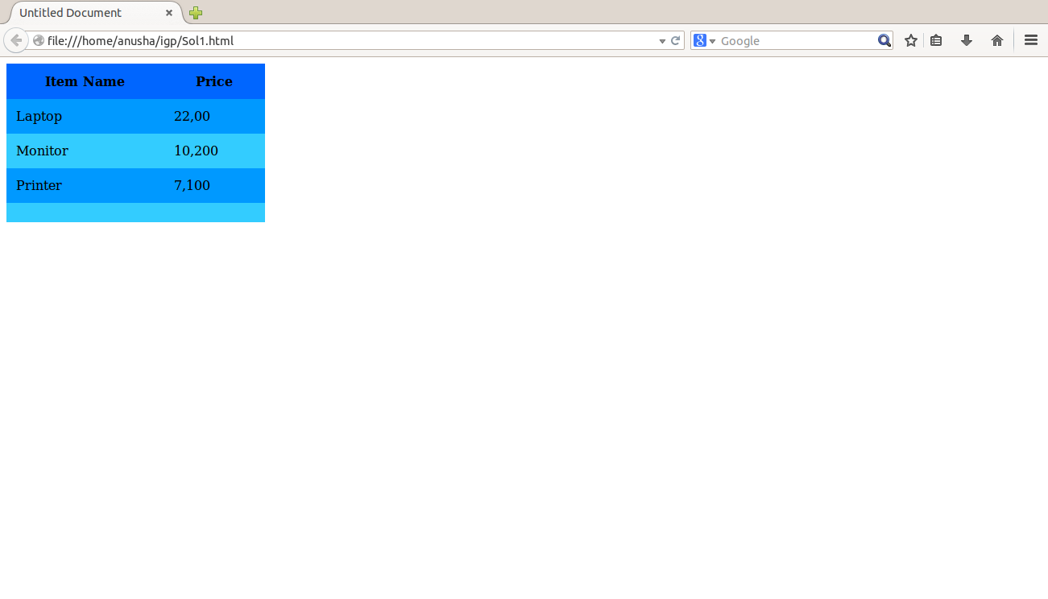

Sol 2:-

<!DOCTYPE html PUBLIC "-//W3C//DTD XHTML 1.0 Transitional//EN" "http://www.w3.org/TR/xhtml1/DTD/xhtml1-transitional.dtd">

<html xmlns="http://www.w3.org/1999/xhtml">

<head>

<meta http-equiv="Content-Type" content="text/html; charset=utf-8" />

<title>Untitled Document</title>

</head>

<body>

<ul><li>Comedies

<ul type="circle">

<li><a href="#">As You Like It.</a></li>

<li>All's Well That Ends Well</li>

<li>A Midsummer Night's Dream</li>

<li>Twelfth Night</li>

</ul>

</li>

<li>Tragedies</li>

<ul type="circle">

<li><a href="#">Hamlet</a></li>

<li>Macbeth</li>

<li>Romeo and Juliet</li>

</ul>

<li>Histories</li>

<ul type="circle">

<li>Henry IV (<a href="#">email</a>)</li>

<ul type="square">

<li>Part I</li>

<li>Part II</li>

</ul>

<li><a href="#">Henry V</a></li>

<li>Richard II</li>

</ul>

</ul>

</ul>

</ul>

</body>

</html>

Output:-

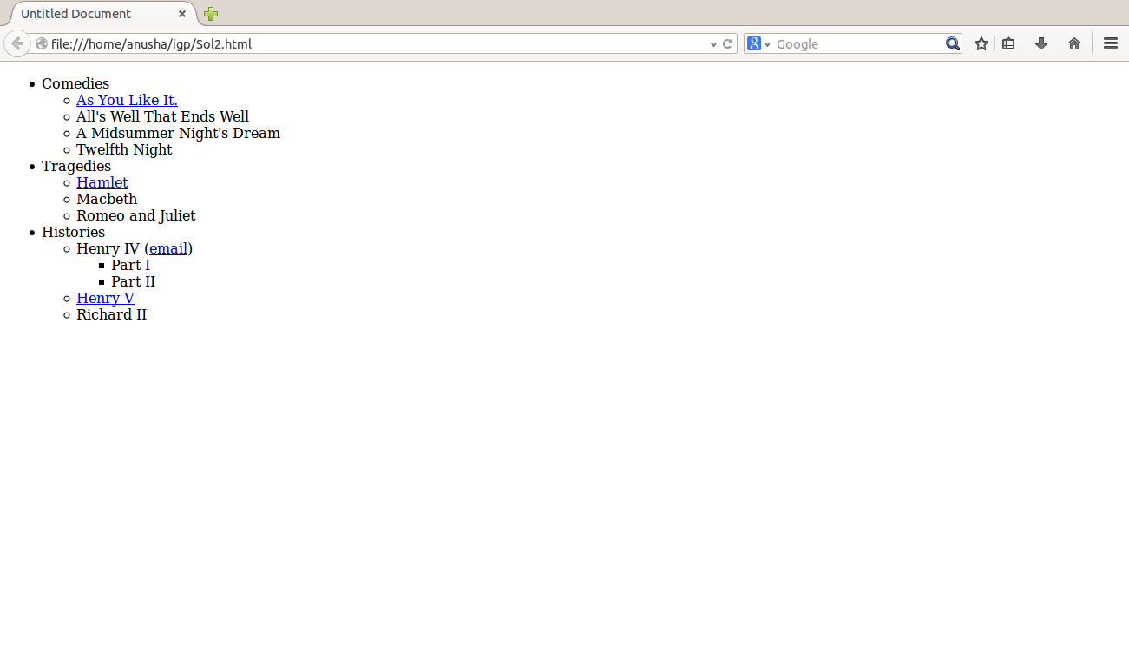

Sol3:-

<!DOCTYPE html PUBLIC "-//W3C//DTD XHTML 1.0 Transitional//EN" "http://www.w3.org/TR/xhtml1/DTD/xhtml1-transitional.dtd">

<html xmlns="http://www.w3.org/1999/xhtml">

<head>

<meta http-equiv="Content-Type" content="text/html; charset=utf-8" />

<title>Untitled Document</title>

</head>

<body>

<table cellspacing="5" cellpadding="8">

<tr>

<td><img src="images/1.jpg" /></td>

<td>Product Id: PS-001<br />

Product Name: Pantene Shampoo<br />

Brand: Pantene<br />

MRP: Rs. 260.00<br />

</td>

</tr>

<tr>

<td><img src="images/2.jpg" /></td>

<td>Product Id: CG-002<br />

Product Name: Colgate<br />

Brand: Dettol<br />

MRP: Rs. 80.00<br />

</td>

</tr>

<tr>

<td><img src="images/3.jpg" /></td>

<td>Product Id: CO-003<br />

Product Name: Cooking Oil<br />

Brand: Sunflower<br />

MRP: Rs. 275.00<br />

</td>

</tr>

<tr>

<td><img src="images/4.jpg"/></td>

<td>Product Id: TS-004<br />

Product Name: TATA Salt<br />

Brand: TATA<br />

MRP: Rs. 35.00<br />

</td>

</tr>

</table>

</body>

</html>

Output 3:-

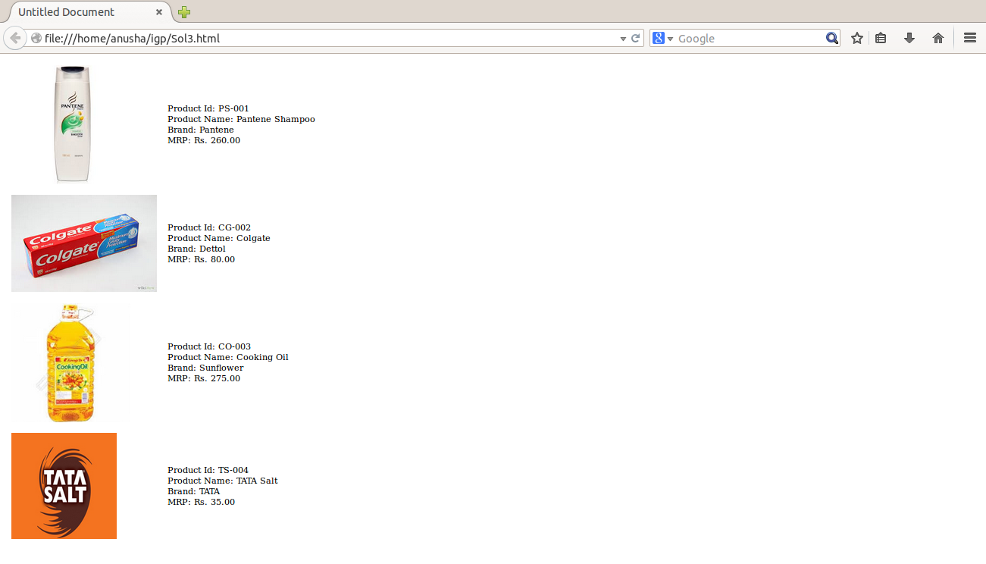

Sol4:-

<!DOCTYPE html PUBLIC "-//W3C//DTD XHTML 1.0 Transitional//EN" "http://www.w3.org/TR/xhtml1/DTD/xhtml1-transitional.dtd">

<html xmlns="http://www.w3.org/1999/xhtml">

<head>

<meta http-equiv="Content-Type" content="text/html; charset=utf-8" />

<title>Untitled Document</title>

</head>

<body>

<form>

<table cellspacing="5" cellpadding="5">

<tr>

<td>Name:</td>

<td><input type="text" id="tb1" /></td>

</tr>

<tr>

<td>Email:</td>

<td ><input type="text" id="tb2" /></td>

</tr>

<tr>

<td colspan="2"><input type="checkbox" id="chkbox1" checked="checked" />Subscribe to the news Letter</td>

</tr>

<tr>

<td colspan="2">Format of the Email:<br />

<input type="radio" id="rb1" name="email" checked="checked"/>HTML

<br />

<input type="radio" id="rb2" name="email" />Plain Text</td>

</tr>

<tr>

<td colspan="2">Type of subscription you want:

<br />

<select>

<option>Standard-Free</option>

<option>Deluxe</option>

<option>Premium</option>

</select></td>

</tr>

<tr>

<td colspan="2">Comments to the editor:

<br /><textarea rows="5" cols="25"></textarea></td>

</tr>

<tr>

<td><input type="submit" id="sb1" value="Submit" text="Submit"/></td>

</tr>

</table>

</form>

</body>

</html>

Output:-

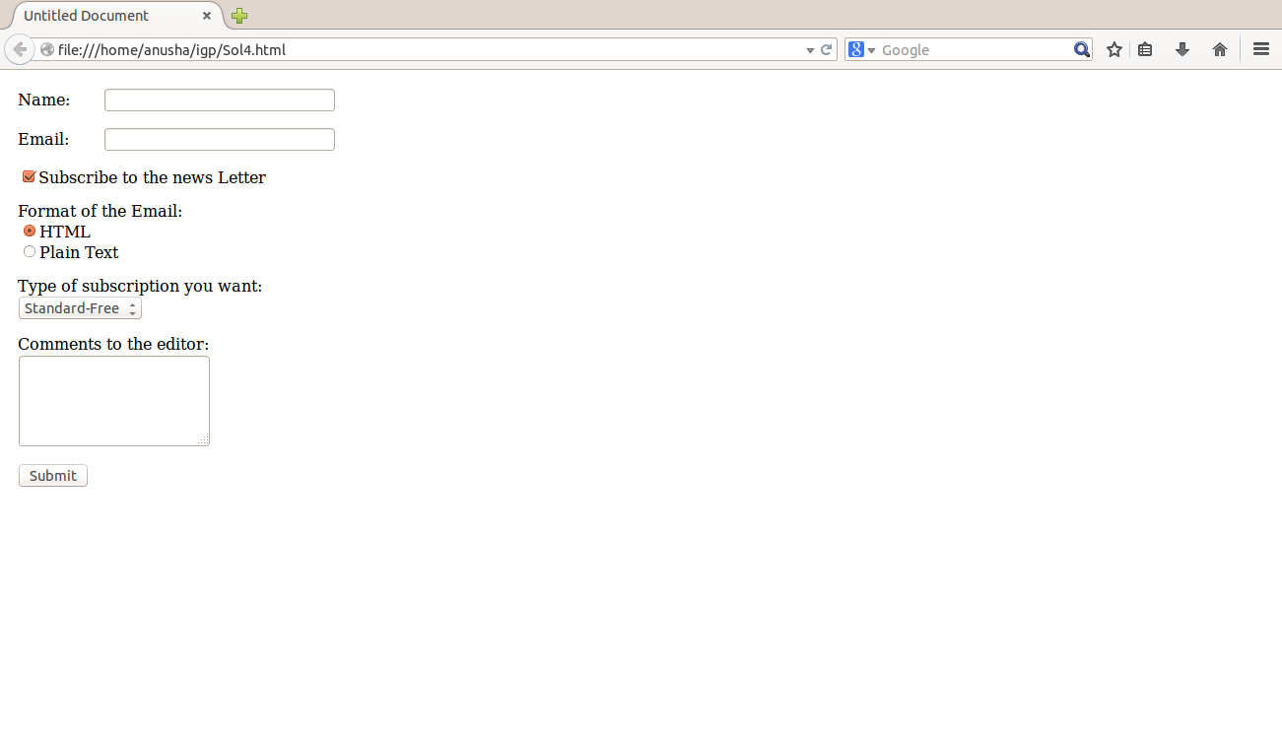

Sol5:-

<!DOCTYPE html PUBLIC "-//W3C//DTD XHTML 1.0 Transitional//EN" "http://www.w3.org/TR/xhtml1/DTD/xhtml1-transitional.dtd">

<html xmlns="http://www.w3.org/1999/xhtml">

<head>

<meta http-equiv="Content-Type" content="text/html; charset=utf-8" />

<title>Untitled Document</title>

<style>

p{

font-family:Arial, Helvetica, sans-serif;

color:#FFF;

font-size:24px;

text-align:center;

}

#inner {

width: 100px;

height: 100px;

background-color:#FF0;

opacity: 0.6;

filter: alpha(opacity=60);

position: absolute;

left: 10px;

z-index: 100;

}

#second {

width: 100px;

height: 100px;

background-color: #00f;

opacity: 0.6;

filter: alpha(opacity=60);

position: absolute;

z-index: 101;

top: 60px;

left: 60px;

}

</style>

</head>

<body>

<div id="inner"></div>

<div id="second"><p>Text</p></div>

</body>

</html>

Output:-

